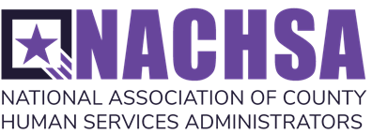

**NACHSA Scholarship Application**

**County Welfare Directors Association of California Conference**

***Bringing It All Together***

**October 11-13, 2023**

**Anaheim, California**

**Apply by August 30, 2023**

The NACHSA scholarship includes conference registration, meals provided at the conference, three nights (maximum) lodging, and roundtrip airfare to/from Anaheim, CA or other nearby airports. The scholar is responsible for the costs of taxis or other personal travel to/from home and to/from the airport to the hotel, and hotel incidental expenses and meals not otherwise provided at the conference. Any subsequent changes made to flight reservations will be the financial responsibility of the scholar.

**Please answer the questions below, save in a word document and email it to Tom Joseph at tj@paragonlobbying.com. Please limit your application to no more than two pages.**

Name of Director or Senior Staff (Applicant):

County Agency:

Street address:

City/State/Zip:

Telephone:

E-Mail:

**BACKGROUND:**

A. Briefly describe your professional background.

**STATEMENT OF NEED:**

Please answer the following.

1. Why I would like to attend the CWDA conference.

1. How my attendance may benefit the programs I administer.

1. How I will ensure that my attendance at the conference will benefit other staff within my county.